Enlighten Festival

Accessibility Guide

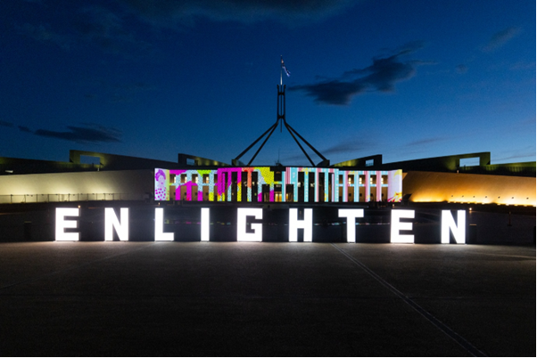

Accessibility and inclusion at Enlighten Festival
You can use this guide to learn about the accessibility services at the Enlighten Festival. It helps you plan your visit and find the information you need.
The festival takes place in the National Triangle in Parkes, Canberra. You can use step-free paths, accessible toilets and other services that support your visit.
Main accessibility services:
- Accessible parking, drop-off zones and a free accessible shuttle bus
- Accessible toilets, including a Changing Places facility
- Mobility hire, including wheelchairs and electric scooters (bookings required)
- Sensory Friendly Night with reduced sound and lighting (Monday 2 March)
- Free Audio Description Tours for people who are blind or have low vision (Monday 2 and Saturday 7 March).
You can plan ahead using the Enlighten interactive map or contact the events team if you have specific access needs.

Plan your visit
We suggest you plan ahead before the event, using the interactive Enlighten Map. You can also contact the event team if you have specific access requirements.

Enlighten interactive map
You can use BindiMaps, an accessible digital map of the National Triangle, to find your way around Enlighten.
You can use the interactive map to:
- Plan your visit from home with directions straight to the festival gates
- Find your way between illuminations, installations, food vendors, stages and services
- Explore more than 100 points of interest
- Choose routes that suit you, including walking, driving, cycling or wheelchair‑friendly options
- View information in 9 languages to support visitors from around the world.
View the Enlighten interactive map on the website:
https://enlightencanberra.com/interactive-map/
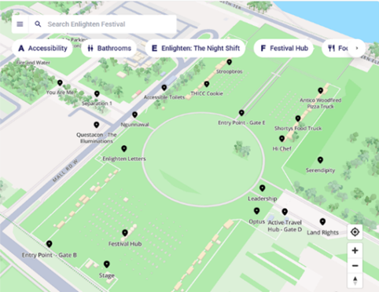

Enlighten site map
You can use the printable PDF site map to see points of interest across the festival. The map shows the layout of the National Triangle and highlights locations, facilities and services.
View the Enlighten site map on the website:
https://enlightencanberra.com/event-information/festival-map/
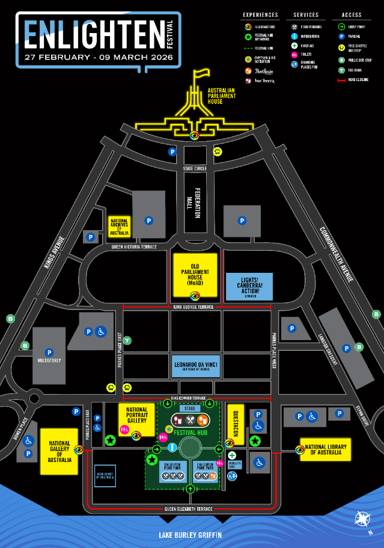

Enlighten accessible site map
You can also download a PDF map that shows recommended accessible routes between points of interest across the festival.
View the Enlighten accessible site map on the website:
https://enlightencanberra.com/event-information/festival-map/

Enlighten Shuttle Bus
A free Enlighten Shuttle bus connects many of the precinct carparks to the Enlighten event site.
The Enlighten Shuttle is wheelchair accessible, starting at 5PM running every 15-minutes.
See further information on the shuttle bus stops and route on the website:
https://enlightencanberra.com/event-information/getting-to-enlighten-festival/
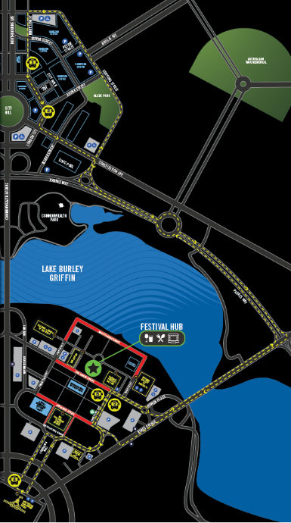

Getting to Enlighten

Drop off zone
A pick-up and drop-off zone is at front of the National Portrait Gallery, on King Edward Terrace for passengers with limited mobility.
The best access to the drop off zone is from Kings Avenue, entering on to King Edward Terrace.
View the location on Google Maps here.
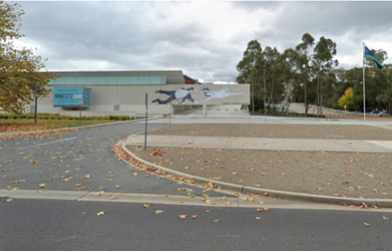

Accessible Parking
You can find accessible parking across the National Triangle. For the closest access to the Festival Hub, you can park at the National Portrait Gallery or the Questacon accessible carpark.
- Questacon carpark: 250 metres from a Festival Hub entry and close to Mobility Hire and First Aid. You must show your accessible parking permit to enter during event hours. View the location on Google Maps here.
- National Portrait Gallery carpark: Free from 5:30 pm to 11:30 pm. Lift access takes you to ground level, and you are 200 metres from a Festival Hub entry. View the location on Google Maps here.
Other accessible parking is available near the National Library of Australia, Australian Parliament House, and the John Gorton Building multi story car park.
Spaces are limited and you need a valid disability parking permit, including those issued interstate or overseas.
Other accessible parking locations can be found across the precinct.

Venue Information
You can experience Enlighten across the National Triangle and at other locations in Canberra.
You can read the sections below to learn more about accessibility at each venue.

The Festival Hub
You can visit the Festival Hub on John Dunmore Lang Lawns. You can access food and drink vendors, an information booth, entertainment and art installations. The area includes paved, concrete and grass surfaces. The main stage and dining areas sit on grass, where wheelchair‑accessible tables are provided.

The Illuminations
You can view the Enlighten Illuminations from February 27 to March 9 on the buildings around the National Triangle, including:
- Australian Parliament House
- National Library of Australia
- National Gallery of Australia
- Questacon
- National Portrait Gallery
- Museum of Australian Democracy.

Symphony in the Park
You can attend Symphony in the Park on Sunday 8 March at Stage 88 in Commonwealth Park.
- Accessible parking: You can use limited accessible parking at Regatta Point.
- Pathways: You can move through a mix of paved walkways and grassed areas across the site.
- Accessible viewing area: You can use a dedicated viewing area if you use a wheelchair. You will need to cross a grassed section to reach this area, as there are no paved paths. Event staff and volunteers can direct you to the viewing area.
See more information about accessibility at Symphony in the Park on the website:
https://enlightencanberra.com/program/symphony-in-the-park/

Lights! Canberra! Action!
You can attend Lights! Canberra! Action! on Friday 6 March at the Senate Rose Gardens.
- Closest Accessible Parking: You can use accessible parking on Newland Street, outside the Treasury Building. This parking is about 400 metres from the entry.
- Pathways: The site includes a mix of paved walkways and grassed areas.
- Accessible Viewing Area: A dedicated viewing area is prioritised for patrons using wheelchairs.
See more information about accessibility at Lights! Canberra! Action! on the website:
https://enlightencanberra.com/program/lights-canberra-action/

Enlighten: The Night Shift
You can explore Canberra’s museums and galleries at night during Enlighten: The Night Shift.
Accessibility information varies by venue. You can visit each venue’s website to learn more.
- View the Australian Parliament House accessibility information on their website: https://www.aph.gov.au/visit_parliament/plan_your_visit
- View the Old Parliament House accessibility information on their website: https://moadmain.live.moadoph.gov.au/visit/access
- View the National Archives of Australia accessibility information on their website: https://www.naa.gov.au/about-us/accessibility
- View the National Portrait Gallery of Australia’s accessibility information on their website: https://www.portrait.gov.au/content/access/

Enlighten Beyond
You can experience Enlighten: BEYOND at locations across Canberra during the festival. Each venue provides its own accessibility information on its website.
View the list of participating Enlighten BEYOND venues on the website:
https://enlightencanberra.com/enlighten-beyond/

Facilities

Accessible Toilets
You can use four accessible toilets within the Enlighten Festival Hub. These are located at:
- Two permanent accessible toilets on Mall Road West
- Two accessible portable toilets at John Dunmore Lang Place
All accessible toilets have handrails and standard swinging doors.
You can also use additional permanent accessible toilets at the National Portrait Gallery, located just outside the Festival Hub.

Changing Places Facility
A Changing Places facility is available near the Enlighten First Aid Marquee on Mall Road West and includes:
- An adult-sized, height-adjustable change table
- A ceiling-mounted hoist system
- A peninsula-style toilet
- Space for two carers if needed
- A safe, clean and private environment
- An automatic door with clear signage and controlled access
Please visit First Aid on Mall Road West near Questacon Festival entry to have the Changing Places facility unlocked.

Parents and Carers room
A Parents Room is available at the National Portrait Gallery Foyer.

Wheelchair accessible picnic table
Wheelchair accessible picnic tables are located in the Festival Hub.

Water Stations
You can find water refill stations around the Enlighten Festival Hub. You’re encouraged to bring a reusable water bottle. Glass bottles are not permitted on site.

Services

Mobility Hire
You can hire a limited number of wheelchairs, electric mobility scooters and strollers on site.
You can pre-book mobility hire equipment online:
https://events.humanitix.com/enlighten-mobility-hire
The Mobility Hire service is open from 5:00 pm to 10:30 pm, and equipment may be collected or returned at any time within this timeframe.
The Mobility Hire marquee is located on the corner of Mall Road West and Questacon Festival Hub entry.

Audio Description Tour
You can join free Audio Description Tours if you are blind or have low vision. Tours run on Monday 2 March and Saturday 7 March from 7:30 pm to 9:00 pm. Audio is provided through a free headset and receiver.
The tours are free, but bookings are required.
When: Monday 2 and Saturday 7 March
Time: 7:30PM until 9:00PM
Where: Enlighten Festival, meeting place is at Questacon Carpark (accessible off Parkes Place West)
Tickets: This is a free experience, but registration is required. Book your free ticket on the website:
https://events.humanitix.com/enlighten-audio-described-tours

Sensory Friendly Night
You can attend Sensory Friendly Night on Monday 2 March from 5:00 pm to 11:00 pm. Sound and lighting levels are reduced to support people with sensory sensitivities.

Ticketing
The Enlighten Festival is free, but some activities require tickets. You can view the list of ticketed activities on the Enlighten program webpage: https://enlightencanberra.com/program/?category=ticketed-event
You can also ask for ticketing information at the Information Point in the Festival Hub.

On site assistance
Friendly Enlighten staff and volunteers at the entrance gates and information booth are happy to help with any questions you may have.

Companion card
If you need to use a Companion Card, please get in touch with the venue running the event.

Assistance animals
You can bring trained and accredited assistance animals.
They must stay on a lead and under your control.

Tips for Visitors
- Visit midweek for smaller crowds.
- Sensory Friendly Night at Enlighten will be held on Monday 2 March, featuring lower amplified sounds for individuals with sensory processing challenges.
- Use the interactive map to plan your route.
- You can use free accessible parking at Australian Parliament House, the National Portrait Gallery and the large Questacon carpark.

Contact and Feedback

Contact
Enlighten staff and volunteers at the entrance gates can answer your questions and provide assistance.
For further information, email events@act.gov.au or call the Canberra Region Visitor Centre on 1300 554 114 to speak to a member of staff.

Continuous improvement
You can share feedback to help us continue improving accessibility at Enlighten. We update information and onsite services each year, and your suggestions support this work. If you have ideas or feedback, you can email us at events@act.gov.au.

