Enlighten Festival 2026

Accessibility Guide

  - Easy Read version

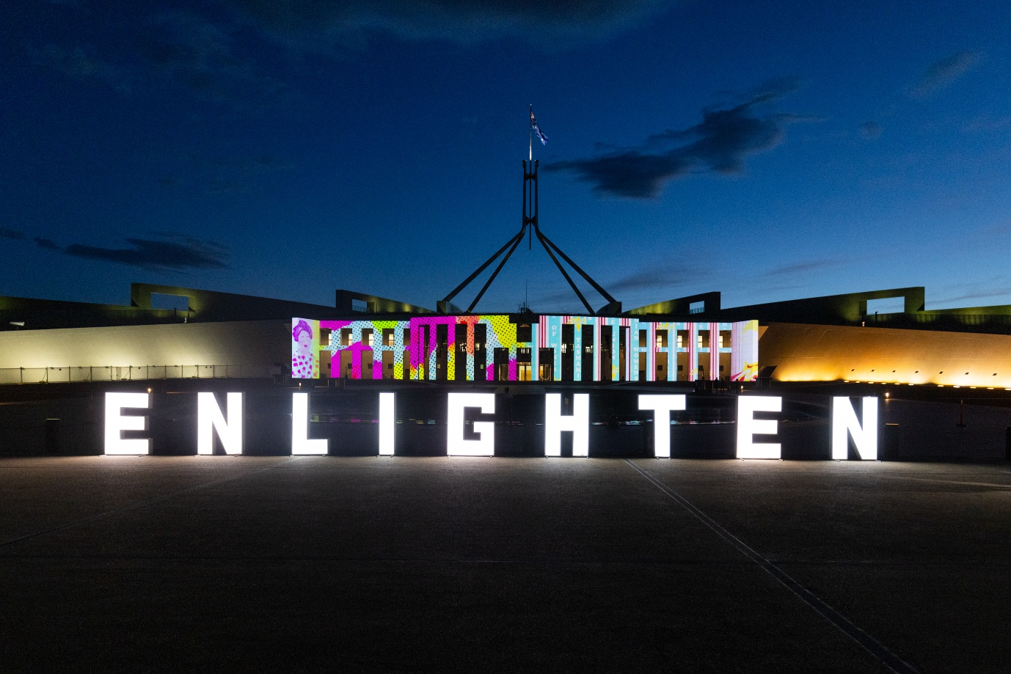


About this guide

This guide is from the ACT Government.



It will use pictures and words to tell
you information.


This guide will tell you about Enlighten Festival
- Enlighten Festival is an event
- it is on in Canberra
- it is on at night
- we will call it Enlighten in this guide

About Enlighten

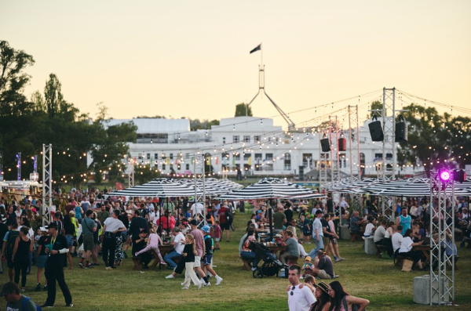

Enlighten is a big event in Canberra.



The event runs from 27 February to 9 March 2026.



It happens outside at night-time.



Everyone is welcome at Enlighten.

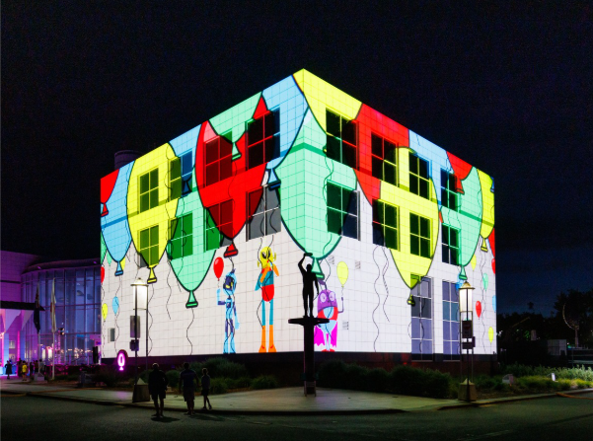
At Enlighten you can see lights on some buildings.

These lights will have moving pictures and sounds.

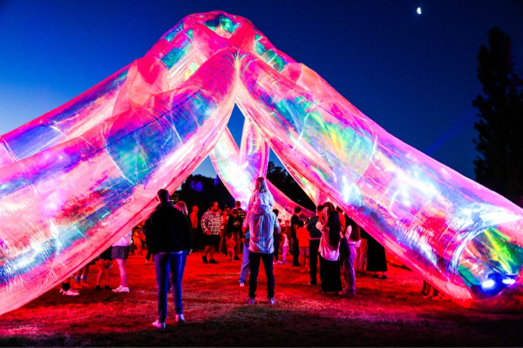

At Enlighten you can see art on show outside.

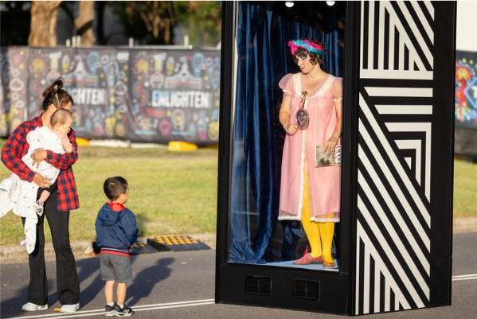
The art will have
- lights
- sounds
- people
- puppets.

At Enlighten
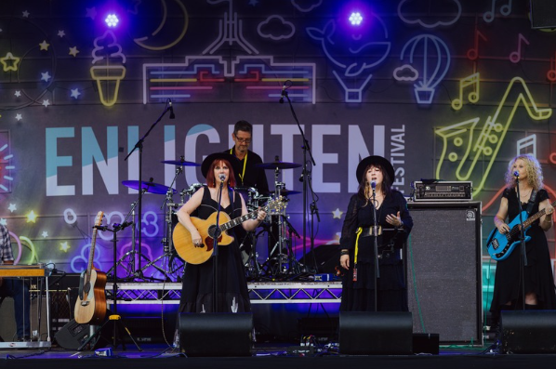

- you can hear live music

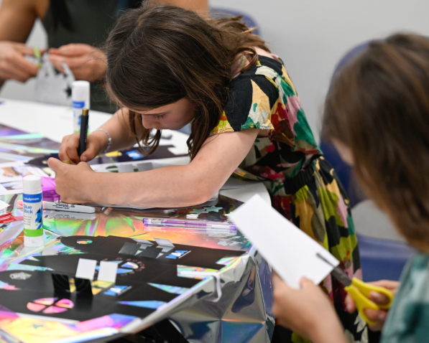

- you can do activities in
some buildings



- you can buy food and drinks

Getting to Enlighten

Location

Enlighten is at the National Triangle in Canberra.

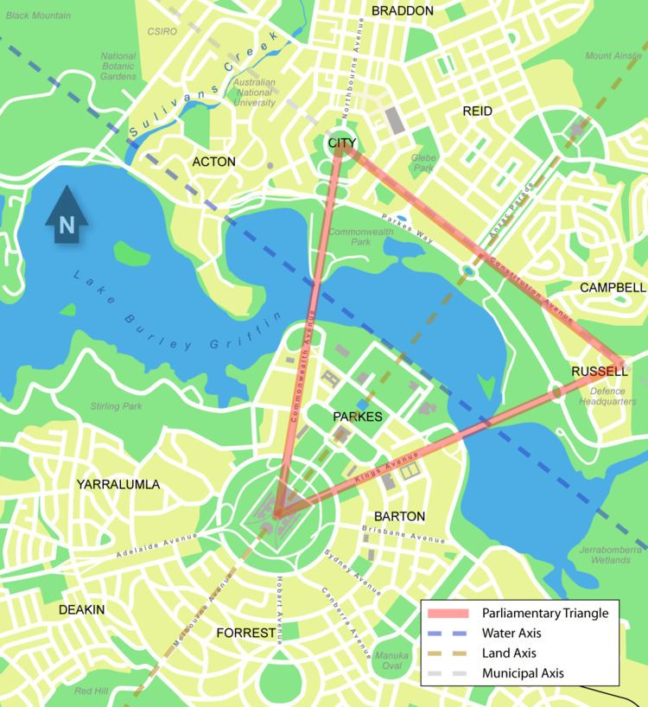
The National Triangle is an area in Parkes, Canberra.
- It is between Kings Avenue and Commonwealth Avenue
- It is from Australian Parliament House to ANZAC Parade
- It includes part of Lake Burley Griffin.
- You can find out more on the website:
www.nca.gov.au/attractions/national-triangle#

Parking at Enlighten
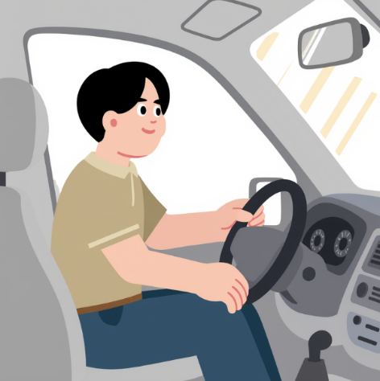

You can drive your car and park
near Enlighten.

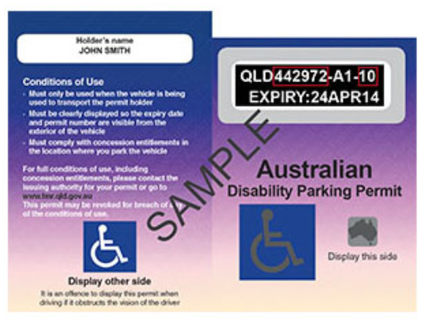

There is parking for people with
disability permits.



You can see where to park on the Enlighten Map on the website:
enlightencanberra.com/event-information/festival-map/

Drop-off and Pickup Point

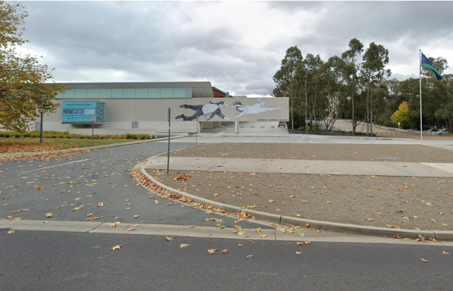
There is a drop-off and pickup point at the National Portrait Gallery.
It is off Kind Edward Terrace.

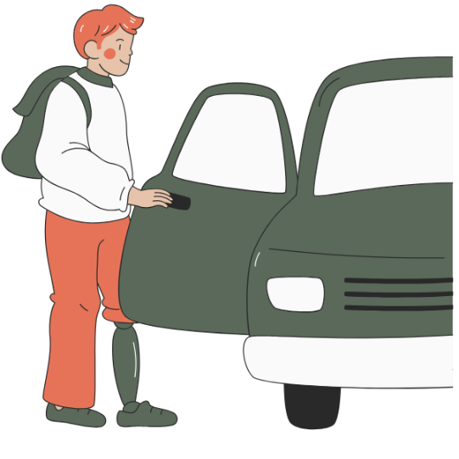
- You can get dropped off by
your driver.

- You can get picked up by
your driver.

Enlighten Shuttle Bus
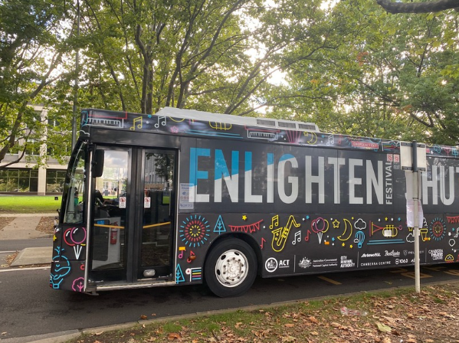
You can catch the shuttle bus to Enlighten.

The shuttle bus is free.

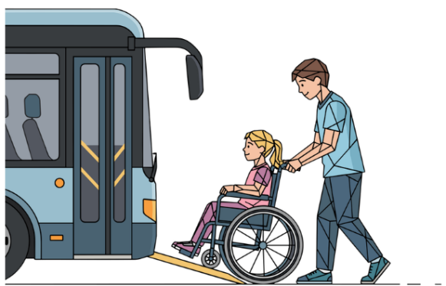
The shuttle bus
- has an accessibility ramp
- has a low, flat floor

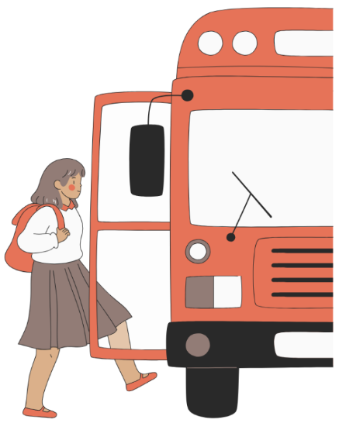
The shuttle bus can pick you up from and drop you off at:
- Civic Bus Interchange
- London Circuit, Civic
- Enlighten
- Australian Parliament House


You can see the shuttle bus times and map on the website:
enlightencanberra.com/event-information/getting-to-enlighten-festival/

Getting Around Enlighten


You can walk around the event to see the lights and art.

The Enlighten area is big.

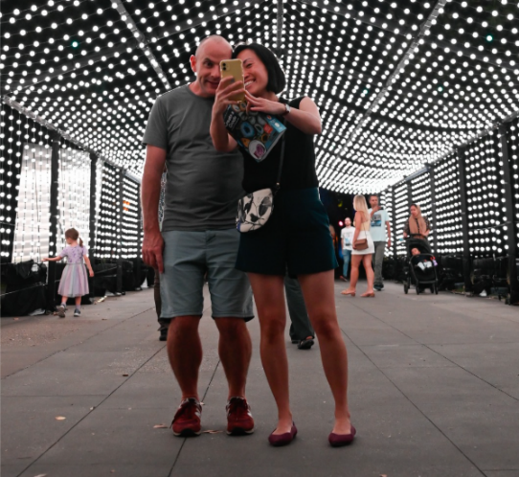

Some of the footpaths are paved.

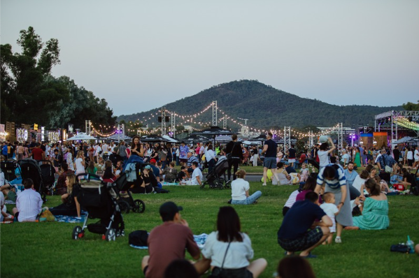

Food and music areas are on grass.

Enlighten Maps
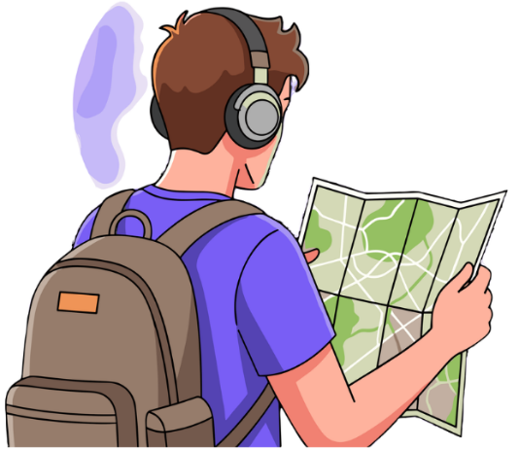

You can use a map to find things
at Enlighten.

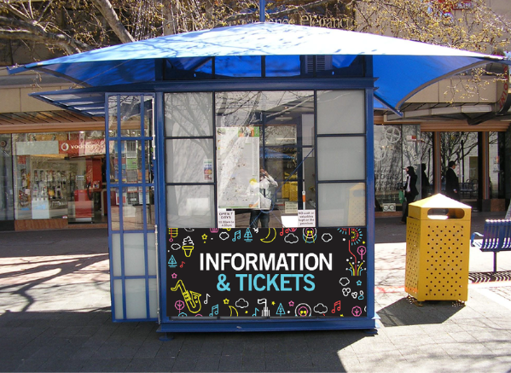
You can get a map from the information booth at Enlighten.
It is in the Festival Hub at
Reconciliation Place.

You can see the Enlighten map on
the website:
enlightencanberra.com/event-information/festival-map/

Interactive Map
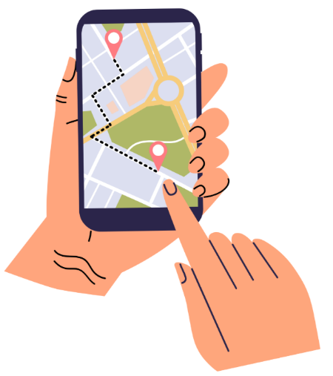
You can use a, interactive map called BindiMaps.

You will find BindiMaps on the website:
enlightencanberra.com/interactive-map/



You can use BindiMaps to plan your visit from home.

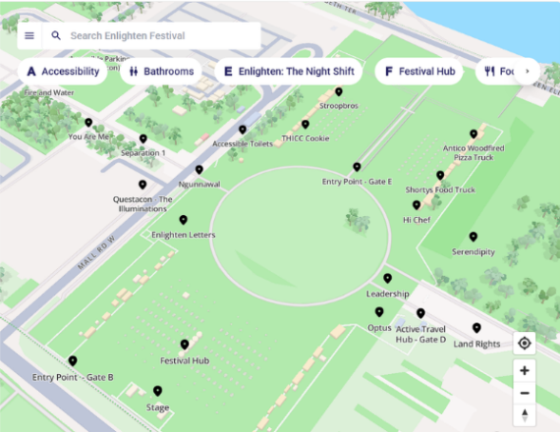
You can use BindiMaps to find
- the lights
- food areas
- parking
- toilets
- paths that are easy to move on.
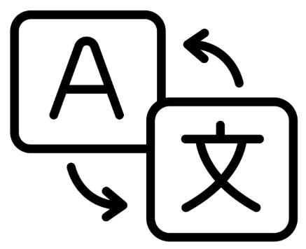

You can choose different languages
on BindiMaps.

How we support you at Enlighten

Mobility Hire
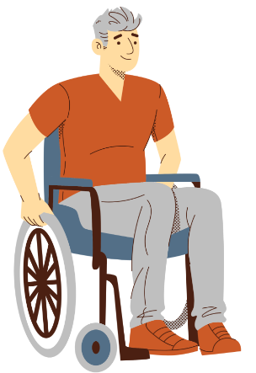
At Enlighten

- you can borrow a wheelchair



- you can borrow a mobility scooter

You can hire them at the website:
events.humanitix.com/enlighten-mobility-hire



You can call us to ask about hire on
0450 962 242.

Accessible Toilets
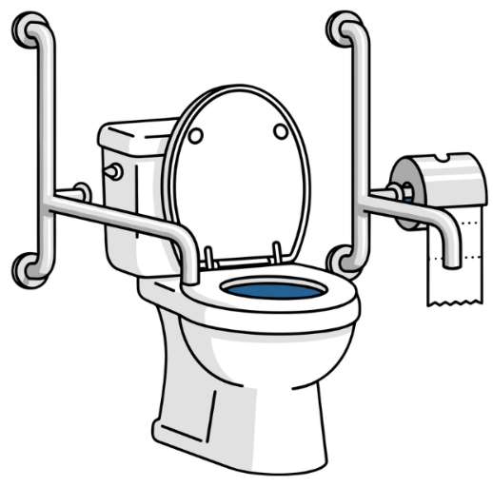
There are accessible toilets at the event.

The accessible toilets:
- have handrails.

- have swinging doors.

You can find the toilets on the map on the website:
enlightencanberra.com/event-information/festival-map/

Changing Places facility

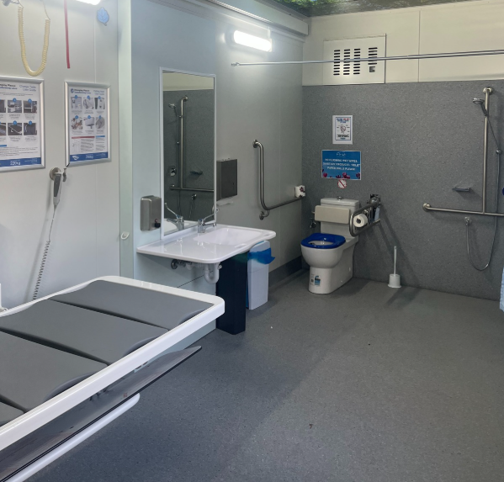
There is a Changing Places facility
at Enlighten.
A Changing Places facility
- is for people who need help to use the toilet
- has more space to move around
- has items to help people use
the toilet.

You can find the Changing Places facility on the map on the website:
enlightencanberra.com/event-information/festival-map/



You must ask someone at the First Aid tent to open it for you.

Sensory friendly night

Sensory friendly night is on Monday 2 March.

It is on from 5:00pm to 11:00pm



- there is less sound.



- there is less light.



This helps people with sensory needs.

Assistance Animals

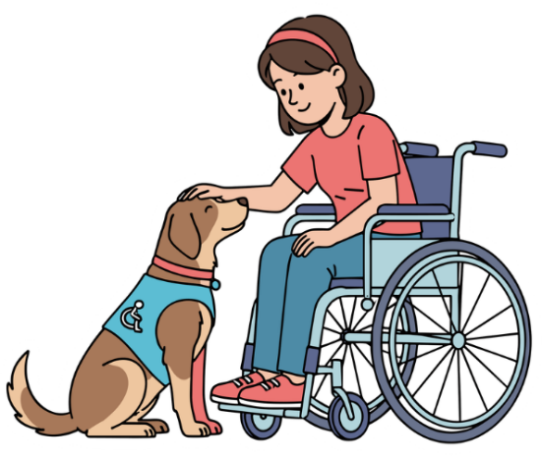
You can bring your assistance animal to Enlighten.

An assistance animal is trained to help you with a disability.
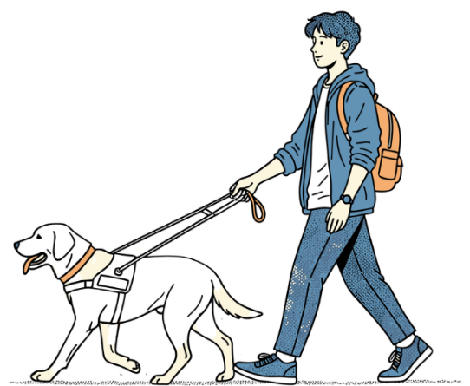

Assistance animals must have a lead on all the time.

Tickets
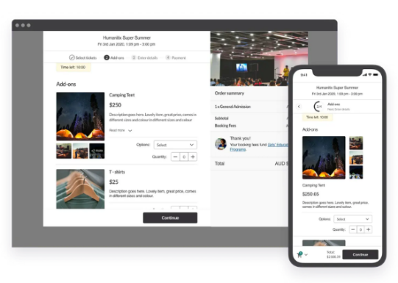
Most of Enlighten is free.

Some activities need tickets.

You can buy tickets on the website:
enlightencanberra.com/program/


Companion Card

To use a Companion card you must ask the people who run the activity.

You can email or call them to ask about Companion cards.

You can find their email and phone number on the website:
enlightencanberra.com/program/

If you need help or more information
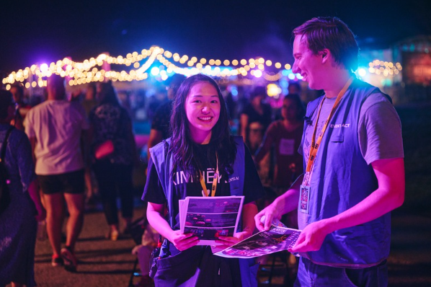

Staff and volunteers can help you at Enlighten.

Before you come to Enlighten:
- You can email us at events@act.gov.au

- You can call the Canberra Region Visitor Centre on 1300 554 114 between 9:00am and 5:00pm.

This is the first Easy Read Guide made for Enlighten Festival.
You can give us feedback to help us improve.
Please email us at events@act.gov.au

